Sample Social Media Posts
Sample Twitter Posts  (280 character limit, 257 character limit with links) | Sample Facebook Posts
We oppose Prop 15, the LARGEST property tax hike in California history. Stand with us and vote NO on Prop 15 in November.  #NOonProp15  #StopHigherPropertyTaxes  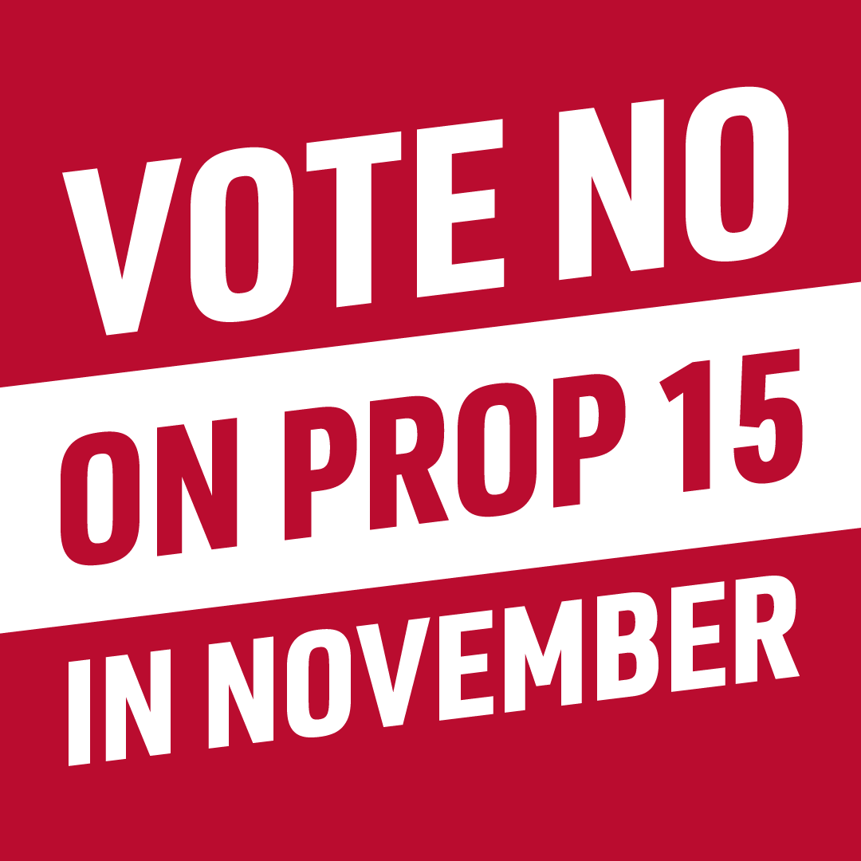 | We oppose Prop 15, the LARGEST property tax hike in California history. Stand with us and vote NO on Prop 15 in November.  #NOonProp15  #StopHigherPropertyTaxes
We urge you to vote NO on Prop 15, the LARGEST property tax hike in state history in November.  Join us in opposition!  https://noonprop15.org/join-the-coalition/  #NOonProp15  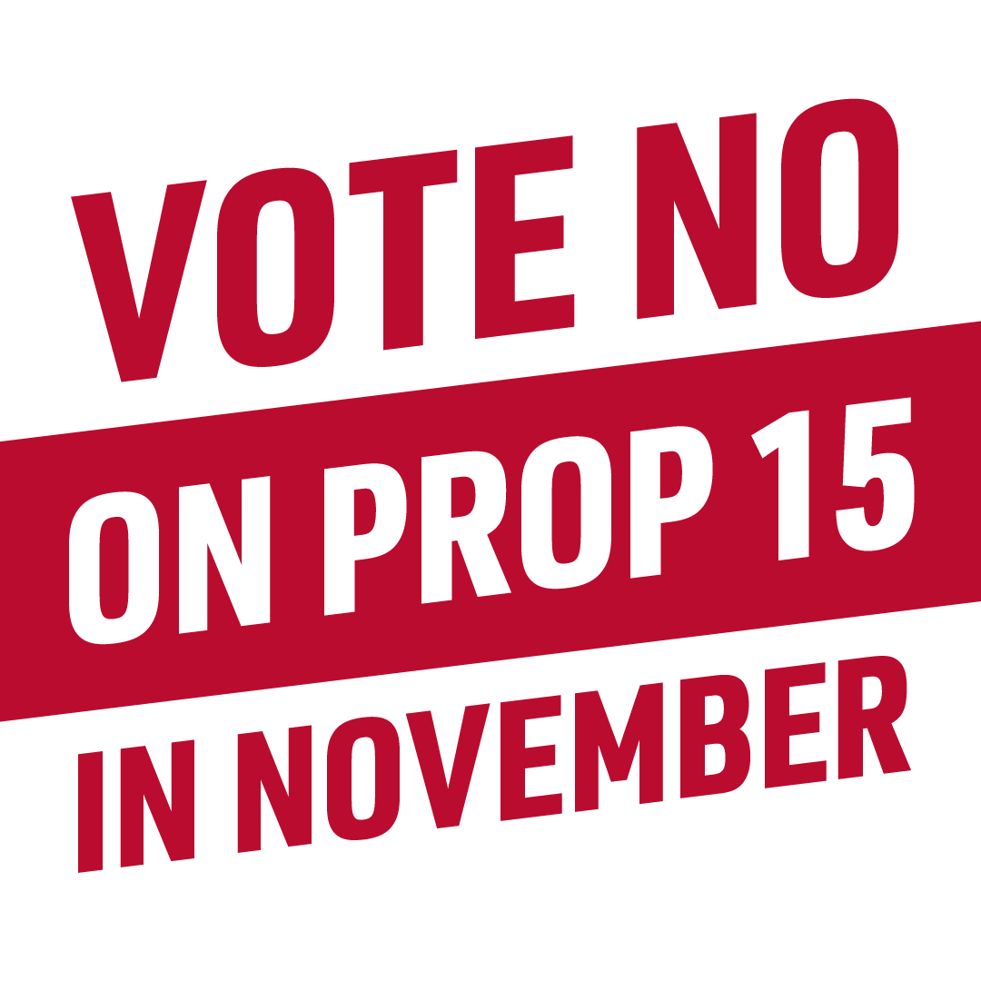 | We urge you to vote NO on Prop 15, the LARGEST property tax hike in state history in November.  Join us in opposition!  https://noonprop15.org/join-the-coalition/  #NOonProp15
Should we really be considering Prop 15 – the largest property tax increase in CA history – when millions of Californians are unemployed? Sounds like a bad idea to us. Retweet if you agree!  #NOonProp15 #StopHigherPropertyTaxes | Should we really be considering Prop 15 – the largest property tax increase in CA history – when millions of Californians are unemployed? Sounds like a bad idea to us. Share if you agree!  #NOonProp15 #StopHigherPropertyTaxes
Prop 15’s $11.5B property tax hike on businesses will get passed on to consumers in the form of higher costs on nearly everything we buy, like groceries, fuel, utilities & health care. Now isn’t the time to raise the cost of living! Share with your friends if you agree!  #NOonProp15  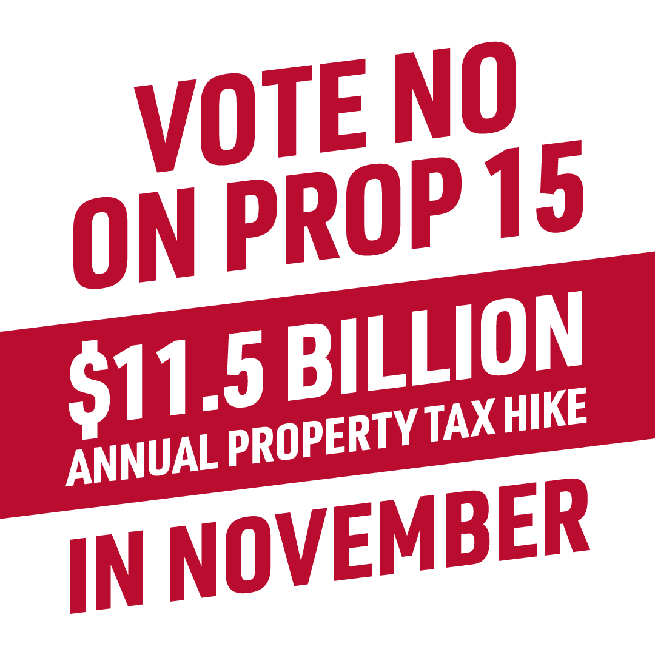 | Prop 15’s $11.5 billion property tax hike on businesses will get passed on to consumers in the form of higher costs on nearly everything we buy, like groceries, fuel, utilities, day care & health care. Now isn’t the time to raise the cost of living! Share with your friends if you agree!  #NOonProp15 #StopHigherPropertyTaxes
Want to know the truth about Prop 15’s massive $11.5 billion-a-year property tax hike on the November ballot? It’s riddled with flaws that will cost every Californian. Check out how Prop 15 will IMPACT YOU.  #NOonProp15  #TaxHikeFlaws  https://noonprop15.org/flaws/ | Want to know the truth about Prop 15’s massive $11.5 billion-a-year property tax hike on the November ballot?  It’s riddled with flaws that will cost every Californian.  Check out how Prop 15 will IMPACT YOU. #NOonProp15  #StopHigherPropertyTaxes  https://noonprop15.org/flaws/
Small businesses have never faced a greater threat than the COVID-19-caused economic crisis.  So why are special interests pushing Prop 15 on the November ballot, a measure that will cause rents to soar for small businesses?  #NOonProp15  #StopHigherPropertyTaxes  #DontTaxSmallBiz | Small businesses have never faced a greater threat than the COVID-19-caused economic crisis.  Many have lost all their income.  Others are uncertain if they can reopen their doors.  So why are special interests pushing Prop 15 on the November ballot, a measure that will cause rents to soar for small businesses?  #NOonProp15  #StopHigherPropertyTaxes  #DontTaxSmallBiz
Did you know that most small businesses rent their property?  Prop 15’s $11.5 billion-a-year property tax hike will mean skyrocketing rents when federal & state govts are trying to provide small businesses with rent relief to keep their doors open.  #NOonProp15 #DontTaxSmallBiz | Did you know that most small businesses rent their property?  Prop 15’s $11.5 billion-a-year property tax hike will mean skyrocketing rents at a time when federal & state governments are trying to provide small businesses with rent relief to keep their doors open.  #NOonProp15  #DontTaxSmallBiz  #StopHigherPropertyTaxes
Prop 15 is an assault on Prop 13’s taxpayer protections—the same protections that have given taxpayers certainty they can afford their property taxes in the future. Prop 15 repeals Prop 13 protections for millions of taxpayers & will mean skyrocketing property taxes!  #NOonProp15 | Prop 15 is an assault on Prop 13’s taxpayer protections—the same protections that have given taxpayers certainty they can afford their property taxes in the future. Prop 15 repeals Prop 13 protections for millions of taxpayers & will mean skyrocketing property taxes!  #NOonProp15
We must vote NO on Prop 15. It repeals Prop 13 protections for small business owners and even some homeowners! Prop 15 will lead to skyrocketing property taxes that could drive many from their homes and force small businesses to close forever.  #NOonProp15 #SaveProp13 | We must vote NO on Prop 15. It repeals Prop 13 protections for small business owners and even some homeowners! Prop 15 will lead to skyrocketing property taxes that could drive many from their homes and force small businesses to close forever.  #NOonProp15 #SaveProp13
Did you know Prop 15 repeals long-standing Prop 13 protections and will make our economic crisis worse? Prop 15’s $11.5B in higher property taxes will raise rents for small businesses and make it even harder for them to keep their doors open.  Like if you’re voting #NOonProp15 | Did you know Prop 15 repeals long-standing Prop 13 protections and will make our economic crisis worse? Prop 15’s $11.5B in higher property taxes will raise rents for small businesses and make it even harder for them to keep their doors open.  Like if you’re voting NO on Prop 15!

